THE DUST OFF TIMES


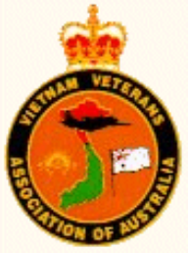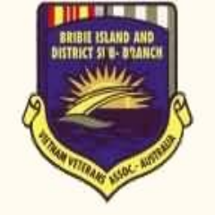
Vietnam Veterans Association Bribie Island & Districts Inc.
P.O.BOX 1001 BONGAREE 4507
Email brivetsbribieisland@gmail.com

Website brivetsbribieisland.com

Honour the Dead but fight like hell for the living

October 2026

EDITORS REPORT

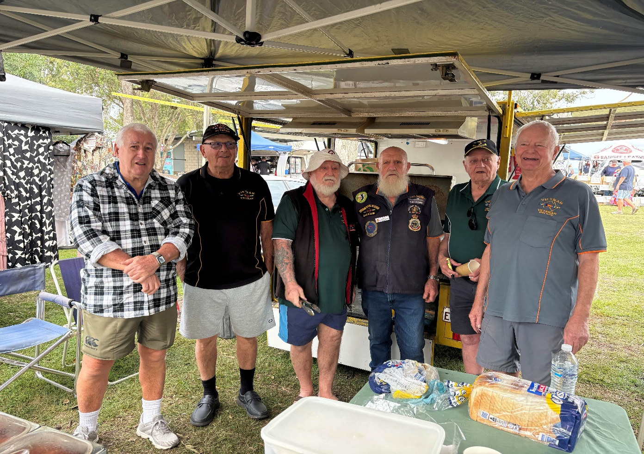
Final Market Day for Benson
The Bribie Island Vietnam Veterans Food Van, affectionately known as Benson, marked the end of an era with its final Market Day recently.
For many years, Benson has been a familiar and much-loved sight within the Bribie Island community. Benson built by the Vietnam Veterans specifically for serving community groups with the best burgers, the finest sausages and the friendliest service with plenty of smiles, but it was much more than just a place to purchase a meal or a drink; it became a meeting place where locals, visitors, veterans and volunteers could gather, share a yarn and enjoy the wonderful spirit of community.
The Vietnam Veterans and their dedicated volunteers have put countless hours into operating Benson over the years, with all involved taking great pride in serving the community.
The final Market Day was a time for reflection and celebration as people gathered to say farewell to a very special part of the Bribie Island Vietnam Veterans community. Many memories were shared, along with stories of the friendships, laughter and good times that Benson has helped create over the years.
While it was a sad occasion for those who have been involved with Benson, the final day was also an opportunity to recognise and thank everyone who has contributed to Benson's success. The commitment of the volunteers, veterans and community supporters has ensured that Benson leaves behind a wonderful legacy.
Although the Bribie Island Vietnam Veterans Food Van may have served its final meal at the markets, Benson will always be remembered as much more than a Food Van. It was a symbol of mateship, community spirit and the dedication of the Bribie Island Vietnam Veterans.
We give thanks to the Veterans who manned Benson on BIDCA Market days, Cancer Council Days, Triathlon Days, Turtle Watch Days, Local State and Federal Election Days, Small Ship Regatta Days, and one of the most memorable was The Rose Festival at Mount Cootha where Benson was the only food outlet, with a huge attendance that left the 5 volunteers breathless during the breakfast and lunch run.

Not everyone managed to get in the final photo for the final day, but a big thank you to all who always helped, including!
WAYNE STELEY, ERNIE HALL, ARNIE LANGSTONE, ROD DEVENISH – MEARES, BRENN VELLACOTT, GEOFF FORSYTH.
MISSING FROM THE PHOTO - PETER WOOD, KEN LANG, PETER JACKSON, COLIN PHILLIPS, DAVID DUNNE, MICK OHLIN, JOHN GREACEN, MICHAEL COLEFAX
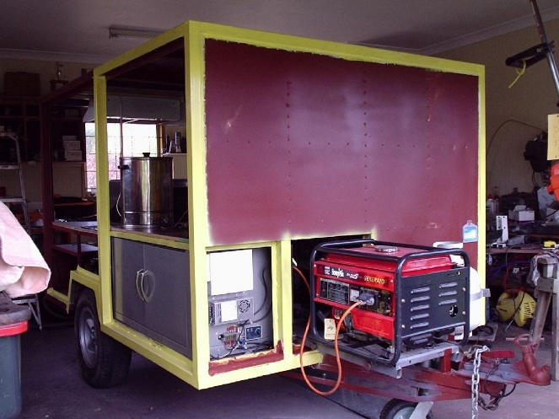
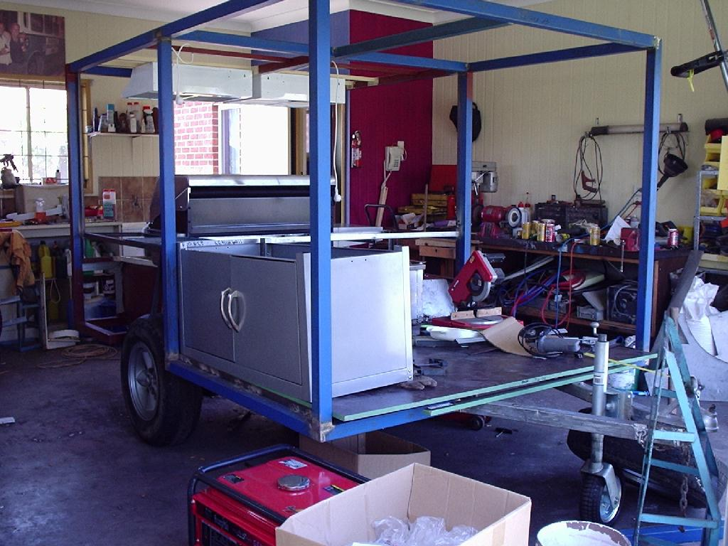

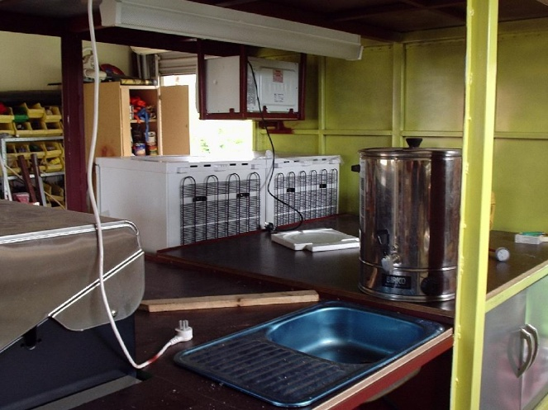
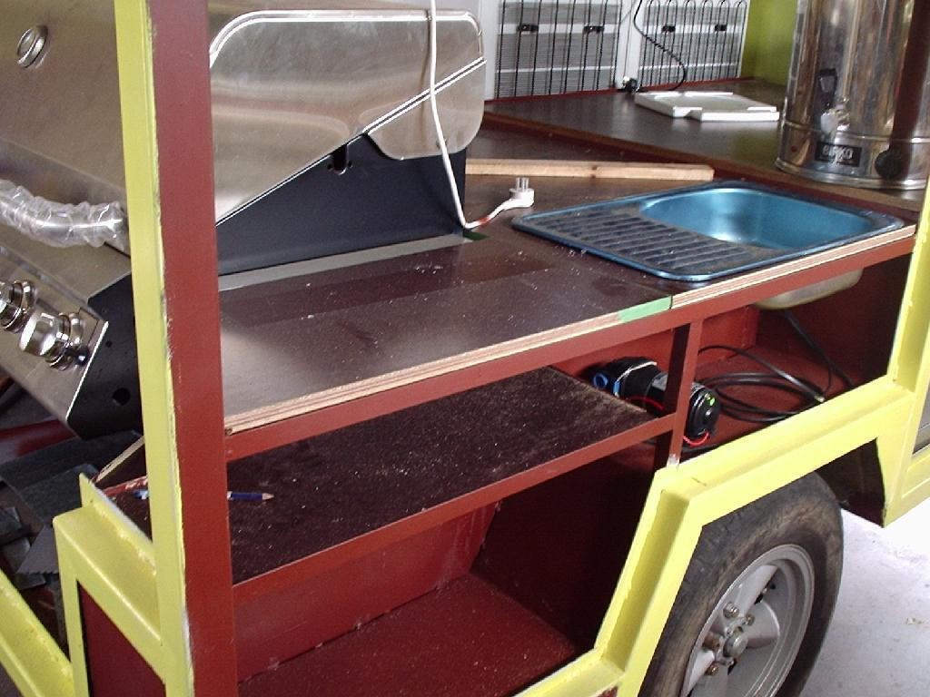

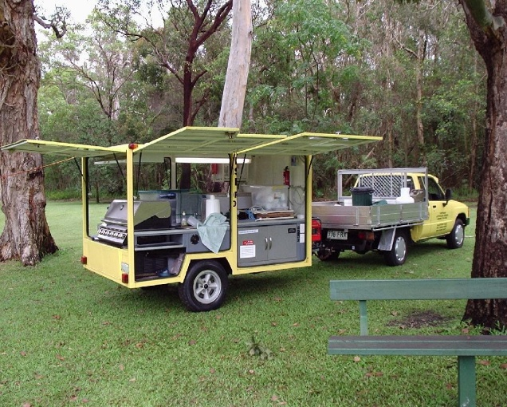
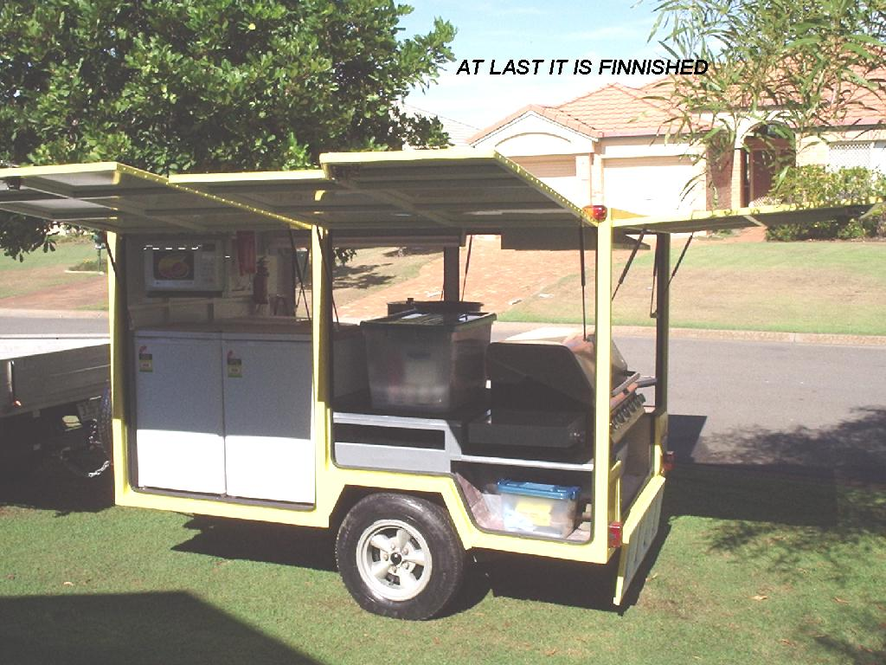

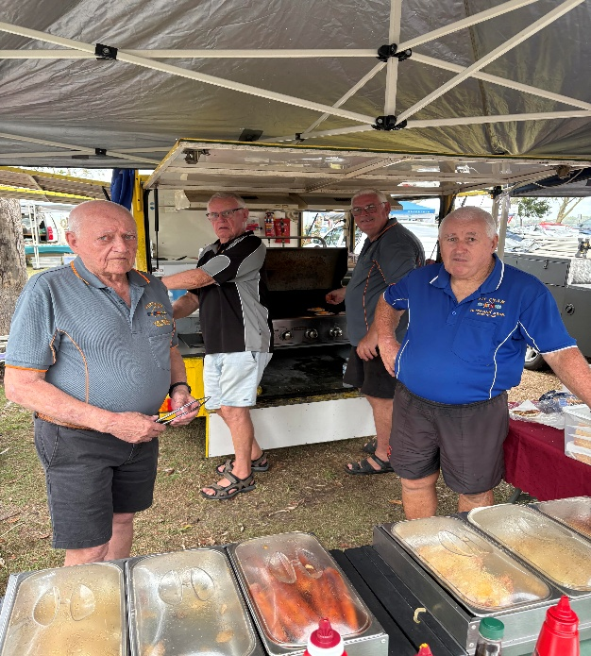
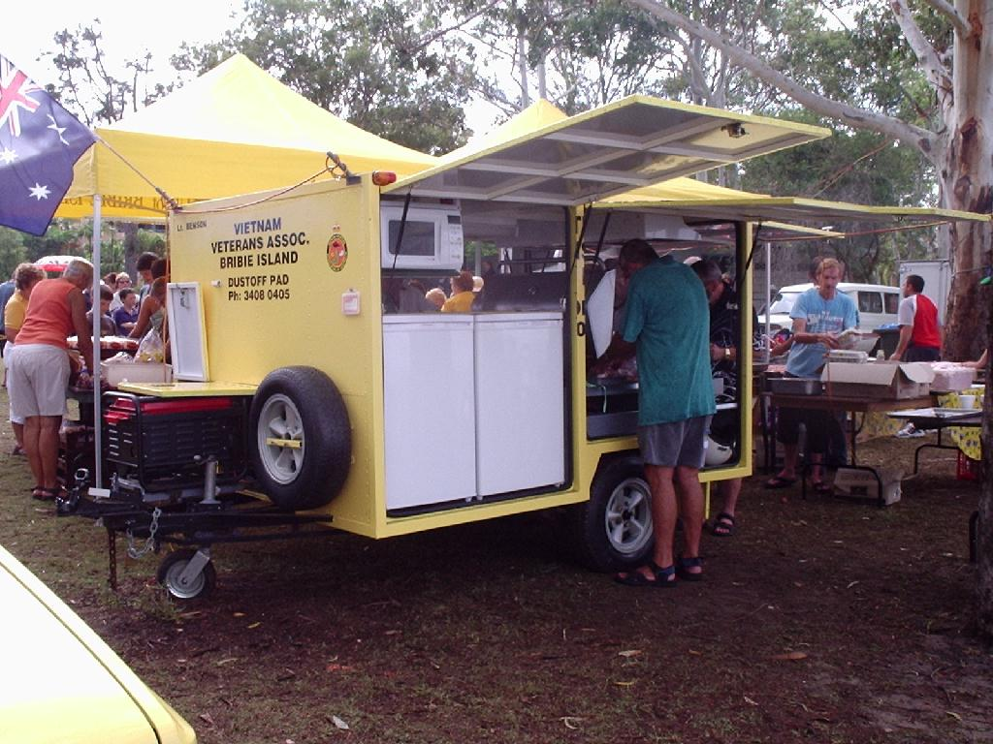

2026 VIETNAM VETERANS DAY
SERVICE AND DINNER

The Vietnam Veterans Day Memorial Service, held on 18th August, was a successful and moving occasion, bringing together veterans, families, friends and members of the local community to honour and remember those who served during the Vietnam War
.
The service provided an opportunity to reflect on the courage, commitment and sacrifice of the Australian men and women who served their country during one of Australia's most significant military conflict.
Veterans proudly gathered to remember their mates and to pay tribute to those who did not return home, and those who have since passed away.
The attendance and support from the community demonstrated the continuing respect and appreciation for Vietnam veterans and their service. It was especially pleasing to see people of all ages come together to acknowledge the contribution made by those who served.

The 18th of August holds special significance as Vietnam Veterans Day, marking the anniversary of the Battle of Long Tan in 1966. The service was a fitting tribute to all Vietnam veterans and a reminder that their service and sacrifice will never be forgotten.

The success of the Memorial Service was due to the efforts of all those involved in its organisation and presentation, together with the wonderful support of everyone who attended.
It was a proud and memorable occasion, ensuring that the spirit of mateship and remembrance continues to live on within the community.

Lest We Forget.
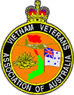

WEDNESDAY RAFFLES AT THE RSL

Raffles at the RSL will now be conducted on Wednesday from 1600hrs onwards, are our main fundraiser and profits go towards maintaining the Park and the Drop-in Centre. We would like to have more support. If you can’t or don’t want to go to the RSL on Wednesday Nights, you can pre-purchase your tickets monthly at the “Monthly Meetings”.

Cost is $2.00 per ticket – Prizes are meat & Seafood vouchers
Each Wednesday there are two raffles drawn.

BRIBIE ISLAND VVAA
UTE - If you need to borrow the Associations’ UTE, it is stored in our own shed. Contact one of the committee members to obtain the keys. Keys are available between the hours of 1000hrs and 1230hrs Monday to Friday. Please refill tank and return the ute to the shed making sure all locks are secured (padlock and centre lock roller door). Return the keys to Committee Member
CLUB T SHIRTS & ASSORTED STICKERS ARE AVAILABLE

If you would like a ‘Tee Shirt’ contact the Secretary 0437 680 382.

For other memorabilia go to the website of the
‘Vietnam Veterans National Merchandise
http://www.vietnamvetmerchandise.com.au
(place cursor over links and hold down control button and click)
ARMY NEWS https://www.defence.gov.au/news/defence-newspapers
NAVY NEWS https://www.defence.gov.au/news/defence-newspapers
RAAF NEWS https://www.defence.gov.au/news/defence-newspapers
RICOCHET https://vietnamvetssc.org.au/ricochet-new/
LONGMAN e-News https://mailchi.mp/c13e555baa83/longman-election- commitments-4083019?e=26da0d44ee
RADSCHOOL http://www.radschool.org.au/

SOME HELPFUL LINKS
https://www.facebook.com/100012897769362/videos/902633143509936/

https://www.covidsafe.gov.au/?fbclid=IwAR0FP8DSfyRKz5hg1nvcqUPitBZHK86Q8COqLg--_dVgDuRZVju-iERVI9U

https://www.awm.gov.au/nwap

http://nominal-rolls.dva.gov.au/
https://www.dva.gov.au/newsroom/latest-news-veterans

Department of Veterans' Affairs – Australia
Veterans Entitlement Act 1986
(electronic version)
Veterans Review Board

Veteran’s Health
DVA Right Mix Alcohol Program

Veterans' and Veterans' Family Counselling Service VVCS

Phoenix Australia | Centre for Posttraumatic Mental Health

Quit Smoking - QUITDAY.ORG
Aged Care Australia
Mesothelioma
Mesothelioma centre
(place cursor over links and hold down control button and click)
The new Website, brivetsbribieisland.com has a large number of the most important links for veterans.

Check out the latest links to National Geographic, You Tube, Service Newspapers, the Navy Heritage Centre, the RAAF Museum and the Australian War Memorial for some great tours plus heaps of entertaining features.

Register via our website for the Melbourne Cup Lunch and for the final event of the year the Veterans Christmas Lunch
FULL DETAILS ON THE WEBSITE

Our Mission Statement to assist all Veterans,
their Dependants and Descendants in all matters relating to their Health, Welfare and Well-being

If you would like to volunteer for fundraising.
Please give your name to the DIC.
Phone 3408 0405

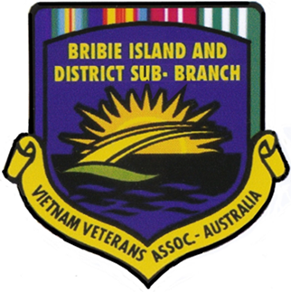

REMEMBER THAT THE MINUTES ARE THE FINAL WORD IN RELATION TO THE RECORDS OF MEETINGS

IMPORTANT DISCLAIMER

The material contained in this publication is in the nature of general comment only, and neither purports, nor is intended, to be advice on any particular matter. Readers should not act or rely upon any matter or information contained or implied by this publication without taking appropriate professional advice which relates specifically to their particular circumstances. The publisher and authors expressly disclaim all and any liability to any person, whether an Association member or not, who fails to act as a consequence of reliance upon the whole or part of the publication. Views expressed in Editorial may not necessarily be those views held by the Executive or its equivalent.

